INVERSE CASCADE IN SPACE TURBULENCE DURING CURRENT DISRUPTION

Anthony Lui
Applied Physics Laboratory, Johns Hopkins University, Laurel, MD, USA

Abstract Wavelet analysis of magnetic fluctuations during space turbulence observed in current disruption events of the Earth’s magnetotail shows that energy is released at progressively lower frequency with time. This feature departs from the expectation of fluid turbulence and arises from the excitation of a kinetic instability in the Earth’s magnetotail current sheet. From insights gained from two-dimensional particle simulation of the instability, it is found that the inverse cascade phenomenon can be identified as the basic property of the excited plasma instability. It is caused by excited waves associated with the instability having slower growth rates with increasing wavelength.

OBSERVATIONS

An example of inverse cascade observed during current disruption in the Earth’s magnetotail is documented in the early study of current disruptions associated with the onset of magnetospheric substorms [1]. Figure 1 shows the measurement of magnetic field components in the magnetotail by the satellite AMPTE/CCE on June 1, 1985. The satellite was located at a downstream distance of ~8.8 RE (RE denotes the radius of the Earth and1 RE = 6378 km) and in the midnight sector [2]. These magnetic fluctuations started at ~23:14 UT and were associated with the occurrence of a magnetospheric substorm.
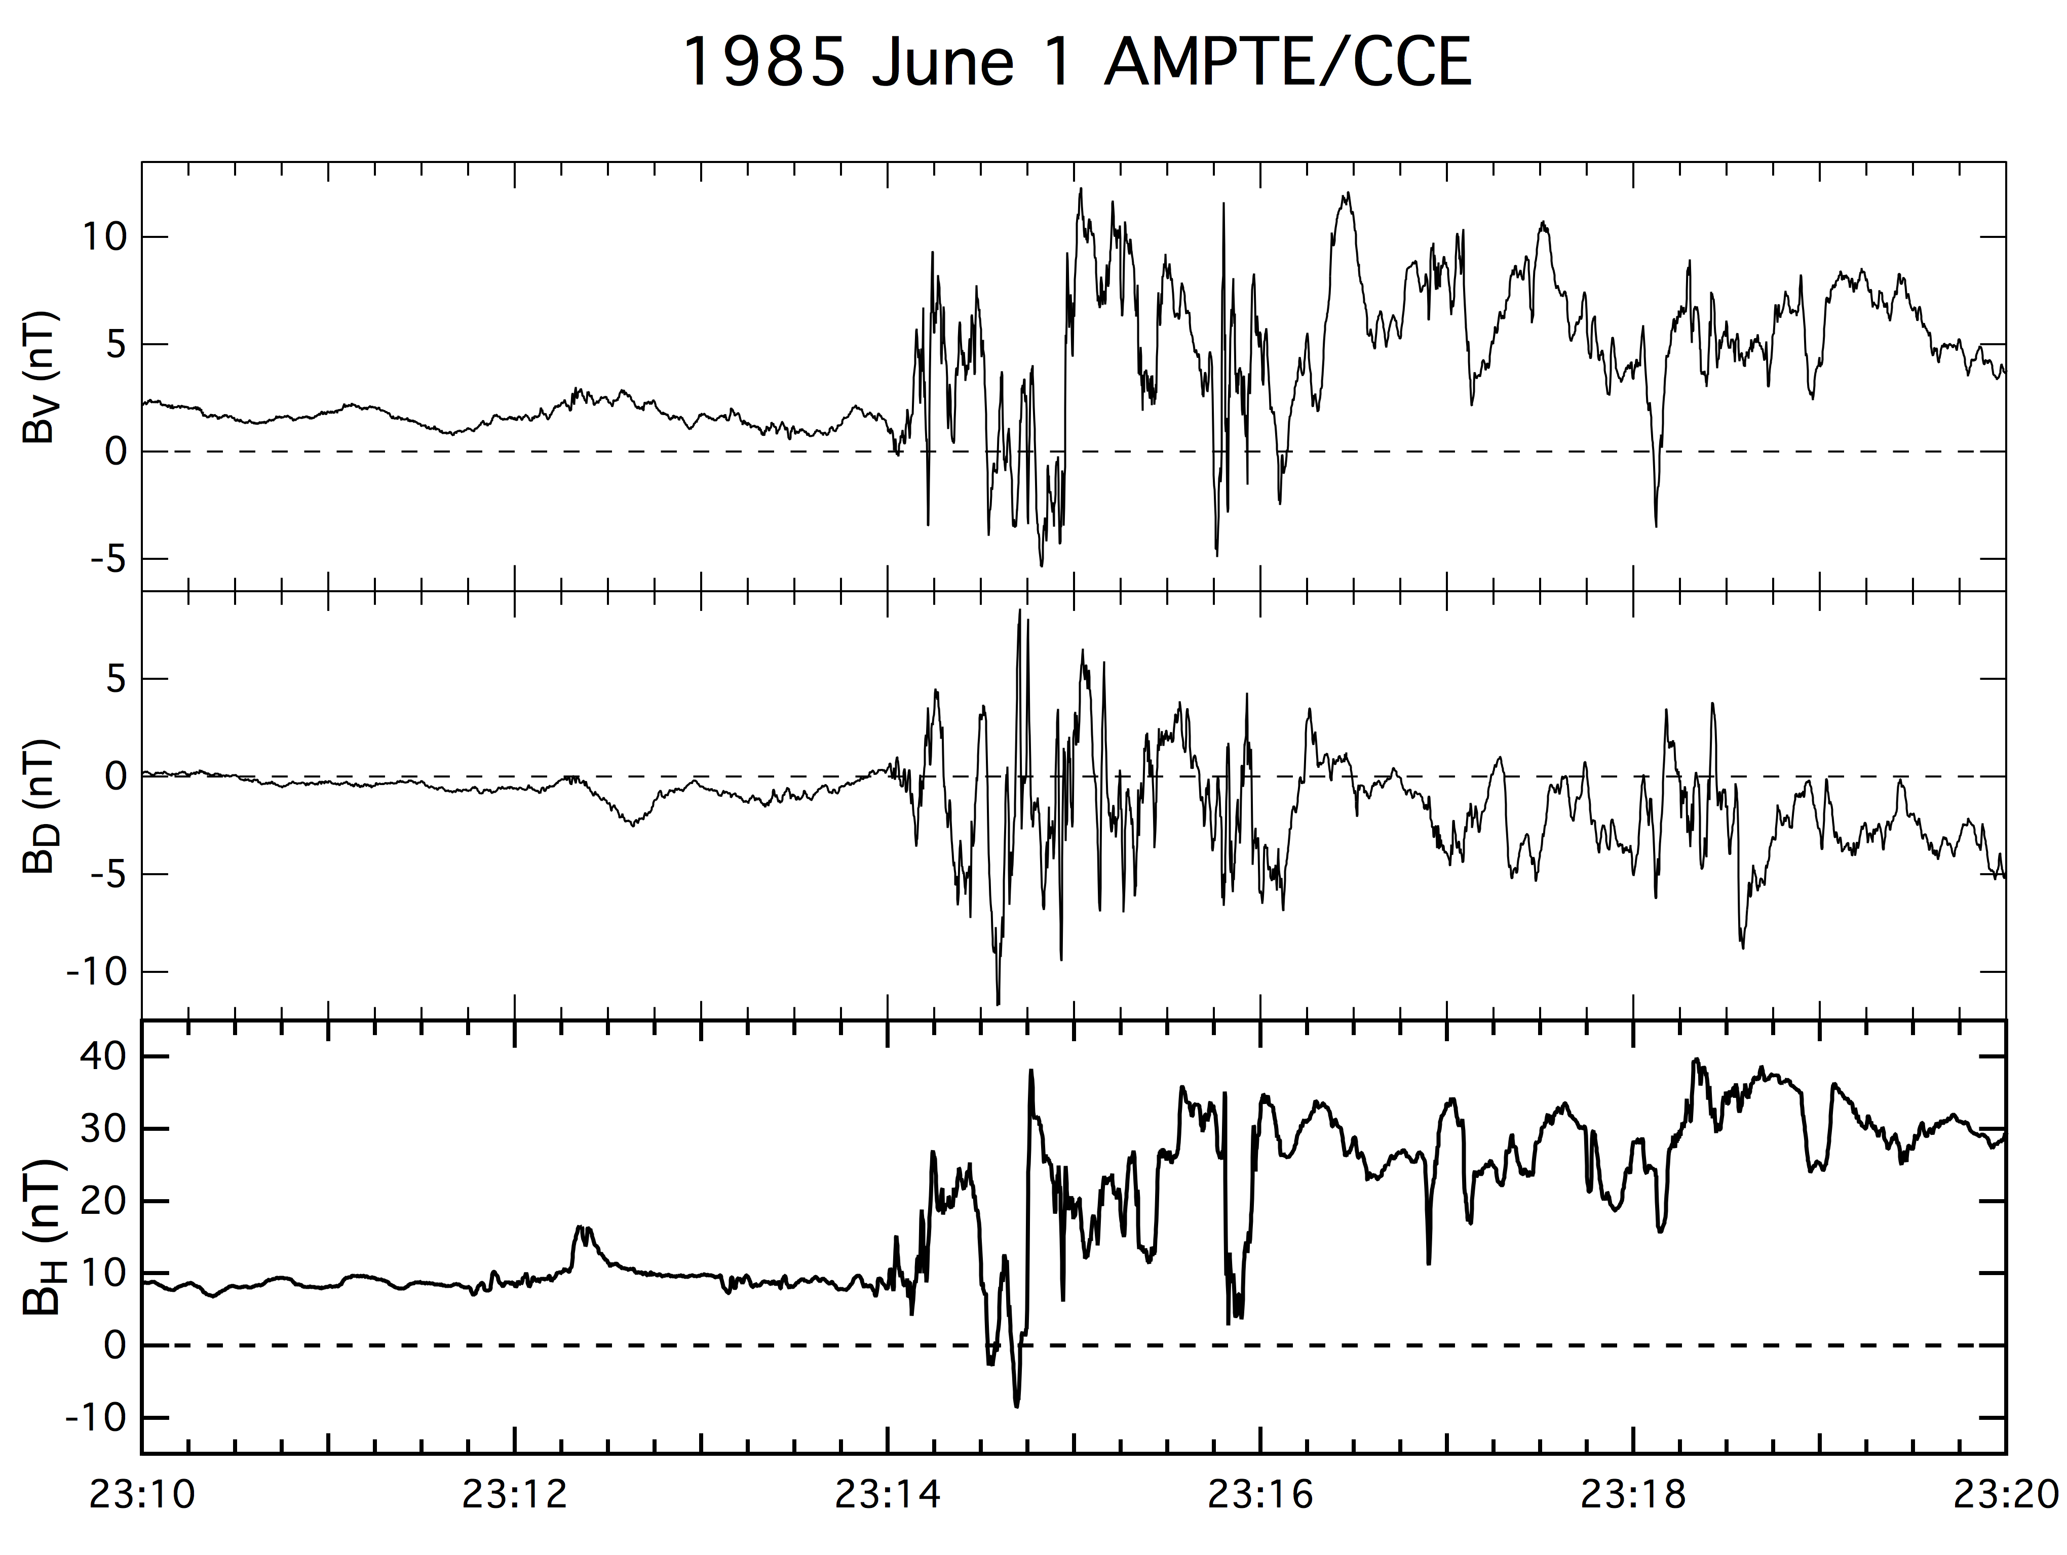

Figure 1. Measurement of magnetic turbulence during a current disruption event.

Wavelet analysis of fluctuations of a magnetic field component Bv shows a distinct inverse cascade feature. Figure 2 shows the result of this wavelet analysis using a continuous wavelet transform [1].

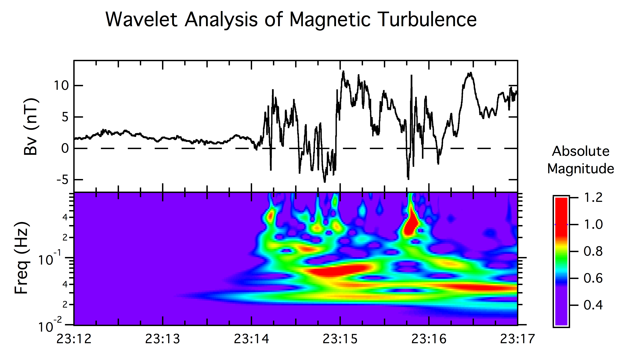
Figure 2. Wavelet analysis of magnetic turbulence during a current disruption event.

TWO-DIMENSIONAL PARTICLE SIMULATIOM OF CURRENT DISRUPTION

A prominent candidate of plasma instability that causes current disruption in the Earth’s magnetotail is the cross-field current instability and its nonlinear evolution has been simulated with a two-dimensional particle-in-cell code [3]. One significant feature from this simulation is the occurrence of inverse cascade, as shown in Figure 3. It is found from this simulation that the inverse cascade phenomenon arises from the intrinsic property of the cross-field current instability in which the growth of excited waves decreases with longer wavelength.

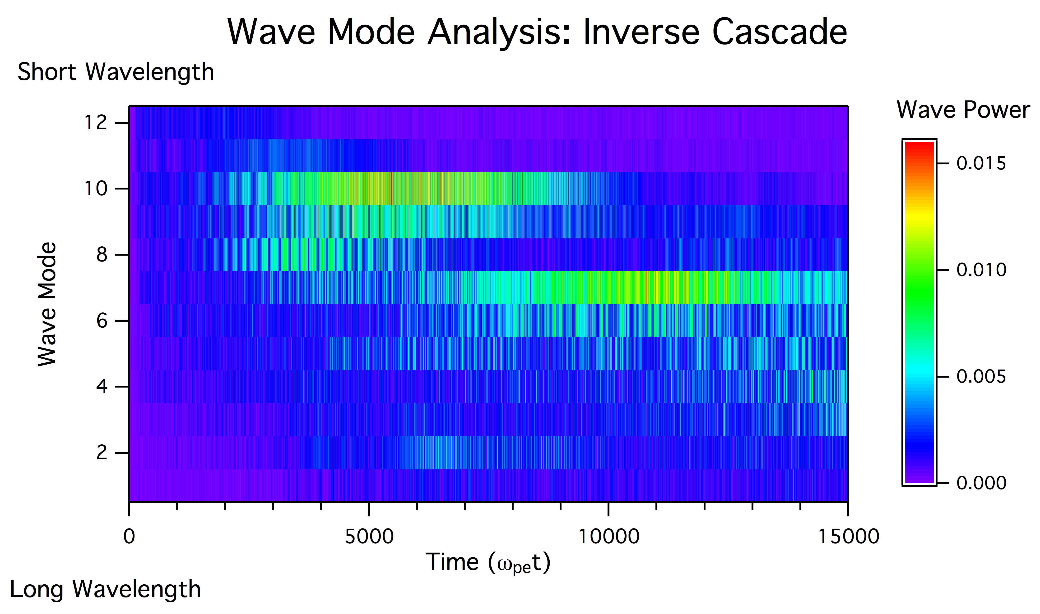
Figure 3. Inverse cascade feature is reproduced from particle simulation of the cross-field current instability.

References

[1] A. T. Y. Lui and A.-H. Najmi. Time-frequency decomposition of signals in a current disruption event, Geophys. Res. Lett., 24, 3157, 1997.
[2] A. T. Y. Lui, et al. A case study of magnetotail current sheet disruption and diversion, Geophys. Res. Lett., 15, 721-724, 1988.
[3] A. T. Y. Lui. Potential plasma instabilities for substorm expansion onset, Space Sci. Rev., 113, 127-206, 2004.

