CAN REYNOLDS STRESS TRANSPORT MODELS BE USED FOR
LARGE EDDY SIMULATION?

J. Blair Perot & Jason Gadebusch
Theoretical and Computational Fluid Dynamics Laboratory, University of Massachusetts, Amherst, USA

Abstract This work explores a route to unify Reynolds averaged (RANS) and large eddy simulation (LES). The approach is to use a slightly modified Reynolds stress transport model for any mesh resolution. The model is formulated in terms of both total kinetic energy and modeled kinetic energy in such a way that the RST model correctly reproduces RANS results, LES results, and even DNS results (by turning itself off). The model equations do not contain functions of the mesh size within any of the model terms or constants. It is demonstrated that this approach works at any mesh resolution. In addition, the model naturally transitions between mesh resolutions, either coarse to fine or vice-versa. It is shown that for LES mesh resolutions the model returns a turbulent length scale that is proportional to the mesh size (the classic LES turbulent length scale).

BACKGROUND

Germano [1] demonstrated that the unclosed (and therefore still unsolvable) partial differential equations (PDEs) governing the time evolution of the Reynolds stresses (for RANS systems) and PDEs governing the evolution of the subgrid stresses (for LES) are identical. However, it does not follow directly from Germano’s work that the models needed to accurately and effectively close those two (mathematically identical) equation systems are also identical. This work tests that stronger hypothesis.

The goal of the study is to experimentally determine if the classic closures used at the RANS Reynolds stress transport equation level can also be effectively applied to subgrid stress modeling. The application of RANS closures at the LES subgrid level has an additional level of ambiguity (or complexity) that this work will attempt to resolve. In particular, at the subgrid level, closure models can use either the unresolved subgrid scale (modeled) turbulence variables, or they can use the total turbulence quantities which include the subgrid scale (modeled) values plus the LES resolved values of that same quantity. There are contexts in the RST model where each type of variable is more appropriate in the closure. This work identifies those circumstances.

Other than this modification of the RST closure (i.e. the need to specify between where to use the total or just the modeled values in the closures), the proposed model makes no attempts to ‘hybrid’ the closure to be tuned to specific regimes (such as RANS,URANS,VLES,LES, or DNS). There is therefore no explicit use or knowledge of the mesh size. No blending functions. No merging of separate RANS and LES models. The LES subgrid-scale model is a properly generalized RST (RANS) model that obtains a classic RANS model in the limit when resolved turbulence is small compared to modeled turbulence, and which obtains the limit of no effect when the resolved turbulence is large compared to the modeled turbulence (DNS limit).
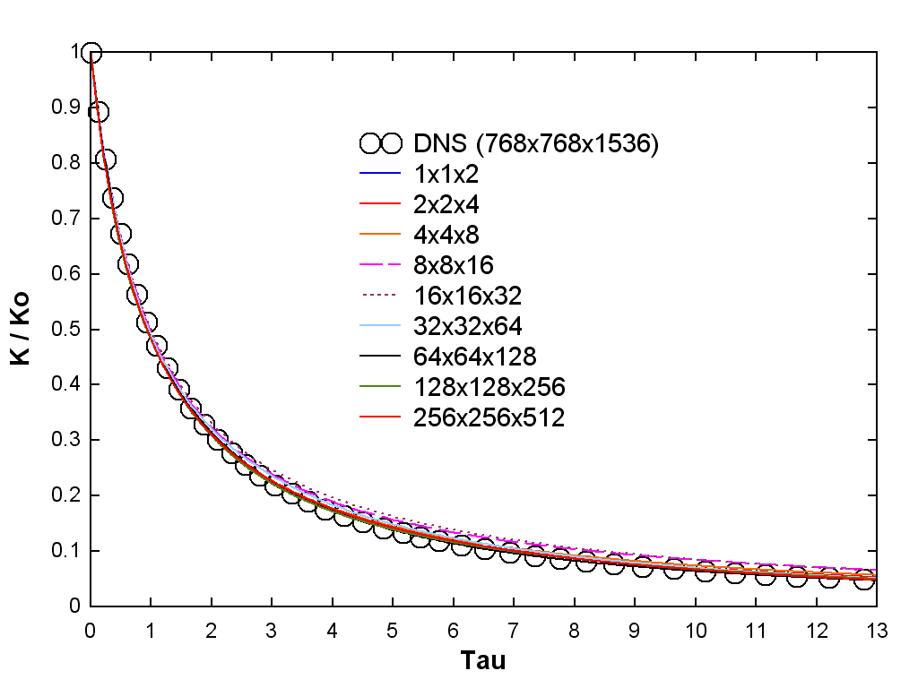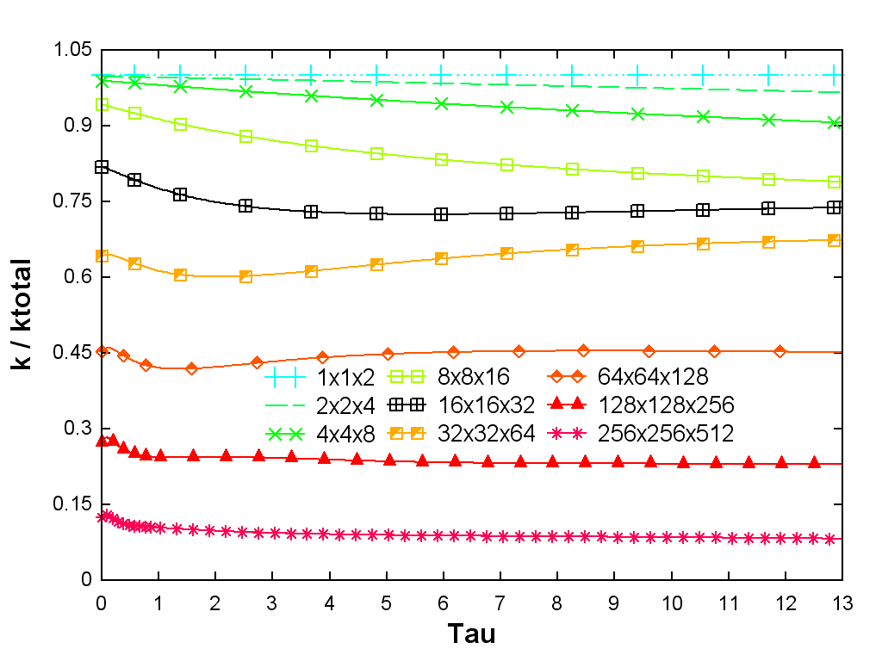
Figure 1. Universal RST model applied to isotropic decaying turbulence on a variety of mesh resolutions displaying RANS to LES to quasi-DNS behavior. Initial. (a) Total kinetic energy vs time (normalized by initial total kinetic energy and initial large eddy turnover time ). (b) Ratio of modeled to total kinetic energy as a function of time.

RESULTS
The results for the universal RST model for isotropic turbulent decay are shown in Figure 1. This figure (part a) shows that the model produces correct predictions for the total turbulent kinetic energy as a function of time at all mesh resolutions. The results (part b) also show that the contributions of the model to this decay are very different for each mesh resolution being simulated. Simulations in which over 80% of the total kinetic energy is being computed by the model (green and blue curves) would typically be considered URANS simulations. Simulations where less than 40% of the total turbulent kinetic energy is being modeled would typically be considered LES simulations.

Note that model works at any resolution, including meshes (such as 32x32x64) where the mesh size is the same size as the energetic eddies (peak in the energy spectrum). This is well outside the inertial range where classic LES theories apply but also far resolved from the range that classic URANS models are designed to handle (half the energy is resolved and should not be modeled). Also note that isotropic turbulence appears to be an overly simple test case (and it is simple for the RANS model). However, at the LES level, the PDEs cannot detect (nor use) the large scale global isotropy of the turbulence. At the LES level, all RST model terms are active, including production and pressure strain (which are based on the local resolved flow conditions).

Figure 2 shows the universal RST models predictions for the length scale () of the unresolved turbulence as a function of the mesh size. At very coarse mesh sizes (4x4x8 and larger) the model returns the classic RANS (large eddy) length scale independent of mesh size. With very fine meshes, the unresolved length scale is proportional to the mesh size (as is assumed by all classic LES models, but not assumed by the universal RST model). Proportionality is given by the dotted reference line. At intermediate resolutions (like 16x16x32), that are inaccessible to LES or URANS, the universal RST model continues to function well and produces intermediate estimates for the length scale.

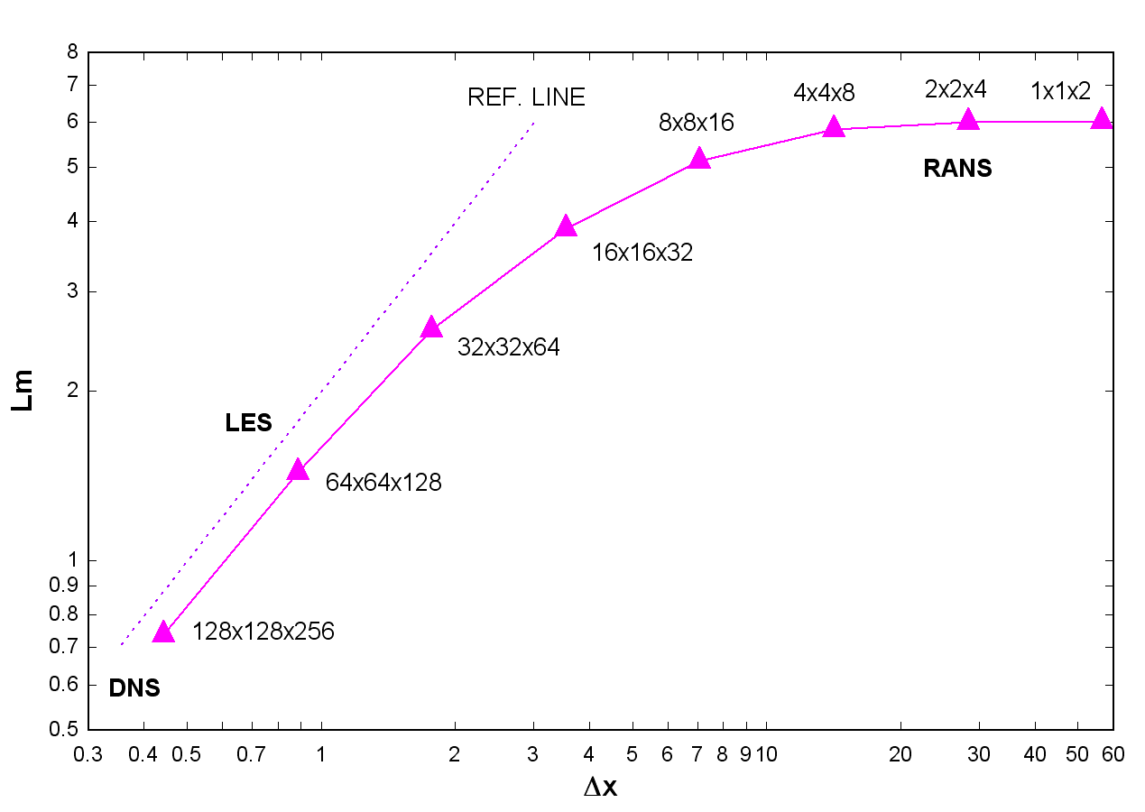
Figure 2. Turbulent length scale predicted by the model versus mesh size at the time = 0.5s.

References

[1] A Germano, M., Turbulence: the filtering approach, J. Fluid Mech. 238, 325, 1992.
[2] Perot, J. B. and Gadebusch, J., A self-adapting turbulence model for flow simulation at any mesh resolution, Phys. Fluids 19, 115105, 2007.

