SUBHARMONIC LOCK-IN AND PHASE SYNCHRONIZATON IN KARMAN STREET DUE TO SURFACE WAVES.
GUNNOO Hans, ABCHA Nizar, GARCIA-HERMOSA Isabel & EZERSKY Alexander
Laboratory UMR 6143 CNRS, Université Caen Basse Normandie, Caen, France

Abstract It is experimentally shown that the action of harmonic surface waves on the turbulent Karman vortex street can provide the shedding frequency lock-in. In our experimental conditions, this effect occurs if the frequency of the surface wave is approximately two times higher than the frequency of vortex shedding. The dynamics of phase fluctuations in the vortex wake of the cylinder is studied using the Hilbert transform technique. On the plane wave frequency – wave amplitude we find an area where phase synchronization of oscillations in the vortex wake occurs.

MOTIVATION AND SCHAMATIC OF THE EXPERIMENT

Effects of external harmonic forcing on the Karman behind obstacle is studied for a long time. Lock-in of the shedding frequency and structures in the vortex wake has been investigated in detail under the influence of the longitudinal oscillations of the cylinder [1]or the flow rate [2]. The process of vortex shedding and synchronization are also investigated under tranversle oscillations of the cylinder [3]. In this report, we examine the influence of surface waves on frequency shedding lock-in of the turbulent Karman street. Now the problem of interaction of surface waves and currents in the vicinity vertical obstacles is important in connection with the widely discussed plans to build wind farms in the coastal zone. In the vicinity of wind farm masts, representing a vertical cylinder, the hydrodynamic fields due to the influence of tidal currents and surface waves are generated. We modeled these fields in a laboratory channel 17 meters long (see Fig. 1). Surface waves are excited by computer controled wave maker, the facilities are also equpped with a pump and a recirculation system that allows to create steady flow U. In order to reduce the intensity of turbulent fluctuations caused by the pump, two honeycombs with a thickness of about 10 cm each are used. The honeycombs are placed in the channel, as shown in Fig. 1. Waves are excited at the end of the channel by the wave maker and they propagate upstream (from the left to the right, see Fig.1). The experiments are implemented with traveling waves because the honeycombs led to a significant decrease in the amplitude of the reflected waves. To measure the velocity fields, three components acoustic Doppler velocimeter (ADV) is used.

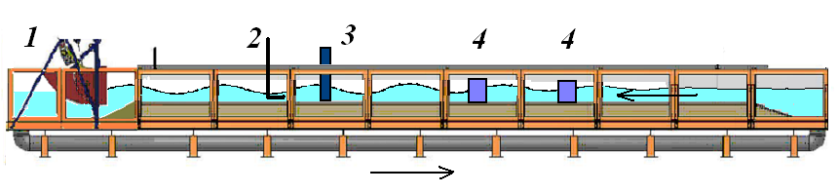

Figure 1. Sketch of the experimental setup. “1” refers to the wave maker, “2” refers to the ADV, “3” refers to the location of the cylinder streamlined by the flow, 4 is for honeycombs; arrows indicate directions of current.

EXPERIMENTAL RESULTS AND DISCUSSION

It is revealed that surface waves with amplitude of only a few mm (maximum value of the slope of the free surface is
10⁻³ in this case) can suppress turbulent vortex street and generate temporally periodic vortex shedding behind a cylinder. Examples of Fourier spectra demonstrating lock-in for a cylinder diameter of d =10 cm (Reynolds number Re =Ud/v= 10⁴, U is flow velocity, v is cinematic viscosity) are shown in Fig. 2 a, b. The spectrum shown in Fig. 2a corresponds to the vortex shedding in the absence of surface waves, and the spectrum shown in Fig. 2b arises under the influence of a wave with frequency f=0.44 Hz. Note that we calculate spectra of transvesal velocity fluctuations for component, where the vlosity field due to the Karman street predominates. As one can see, the spectrum of velocity fluctuations in the absence of a surface wave is a superposition of harmonic frequencies in the frequency interval f_{sh} ~ 0.20 - 0.24 Hz, whereas the effect of surface waves lead to the appearance of sharp spectrum pick with half a frequency of surface wave f~0.22 Hz.
To characterize quantitatively the synchronization effects, we investigated the phase of oscillation in the cylinder wake. For this purposes, the Hilbert transformation of velocity components is performed. Using Hilbert transformation, we are able to determin the phase of velocity oscillation in the wake. The degree of synchronization can be described using the so-called phase diffusion coefficient K [4]. With an increase of wave amplitude (Fig. 2c), the phase diffusion coefficient decreases, where as at large amplitudes it increases. Decrease in the coefficient indicates that the synchronization appears at final amplitude of waves. For sufficiently large wave amplitudes, the synchronization of oscillations in the wake of a cylinder at a Strouhal frequency is completely destroyed. This fact is connected with generation of harmonics with double and triple Strouhal frequency.
It is found that synchronization can lead to a significant growth of the root mean square amplitude of velocity pulsations in the wake of a cylinder. Such growth may attain 50-100% in the neighborhood of the cylinder for the turbulent vortex street. The amplification of velocity pulsations can increase the Reynolds stress in the vicinity of the mast, which in turn can lead to an increase of sediment transport and bottom erosion.
This work was supported by the OFELIA (Offshore Foundations Environmental Impact Assessments) project in the frame of the European cross-border cooperation programme INTERREG IV A France (Channel) - England, co-funded by the ERDF.
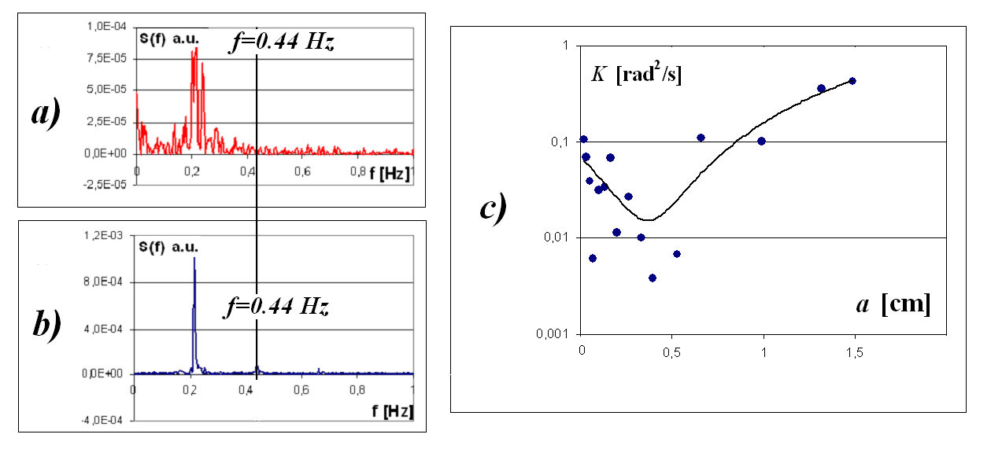
Figure 2. Example of frequency lock-in and phase synchronization :
(a) spectrum of velocity pulsations in a wake behind cylinder in the absence of surface waves,
(b) spectrum of lock-in regime, vertical line indicates the frequency of surface waves,
averaged frequency of velocity pulsations due to vortex shedding is approximately f _{Sh}= 0.22Hz;
(c) dependence of phase diffusion coefficient on surface wave amplitude.

This work was supported by the OFELIA (Offshore Foundations Environmental Impact Assessments) project in the frame of the European cross-border cooperation programme INTERREG IV A France (Channel) - England, co-funded by the ERDF.

References

[1] O.M. Griffin, and S.E. Ramberg. Vortex shedding from a cylinder vibrating in line with an incident uniform flow. J. Fluid Mech. 75: 257–271,
1976.
[2] E.Konstantinidis, S.Balabani, and M.Yianneskis, Bimodal vortex shedding in a perturbed cylinder wake, Phys. Fluids 25: 085109, 2013.
[3] K. Stansby The locking-on of vortex shedding due to the cross-stream vibration of circular cylinders in uniform and shear flows. J. Fluid
Mech. 74: 641- 665, 1976.
[4] A. Pikovsky, M. Rosenblum, and J. Kurths. Synchronization. Universal Concept in Nonlinear Sciences. Cambridge University Press,
Cambrige, 2001.

