Unsteady particle accumulation in wall turbulence

Dmitrii Ph. Sikovsky^{1,2}
¹Institute of Thermophysics of Siberian Branch of Russian Academy of Science, Novosibirsk, Russian Federation
²Novosibirsk State University, Novosibirsk, Russian Federation

Abstract We propose the asymptotic theory of unsteady accumulation of inertial particles in the viscous sublayer of wall-bounded particle-laden turbulent flow. We derive the diffusion equation for the particle concentration in the viscous sublayer and find the self-similar exact solution of this equation at large times. It is shown that near the wall the maximal concentration grows as , while the distance from the wall to the concentration pike as well as its width decay as . The obtained solution is corroborated by the results of stochastic Lagrangian simulations.

In [1] it was shown that the steady-state solution for the kinetic equation for the probability density function of particle position and velocity (PDF) exhibits the near-wall singularity. It was assumed that the infinite time is needed for the point particles to reach such steady solution with the singularity of particle concentration. The aim of the present paper is to study the unsteady accumulation of particles in the viscous sublayer of wall-bounded turbulent flow.
In the thin viscous sublayer the intensity of wall-normal fluid velocity decays to zero as , where is the distance to the wall and wall units are implicit throughout for all variables. Above the viscous sublayer, in the buffer zone the particles interact with the near-wall coherent structures such as the low-speed streaks and energetic streamwise vortices which radius is of order of viscous sublayer thickness. Based on the observations from DNS/Largangian tracking numerical data [2] and the results of asymptotic analysis [1], we can divide the particles on two groups. Particles of the first group are captured by the near-wall energetic eddies and slung toward the wall with the wall-normal velocities of order of one, which are much larger than local . Thus, they are not influenced by the fluid velocity fluctuations and can be referred to as ballistic, or free-flight particles. Particles of the second group are trapped by the low-speed streamwise streaks and have velocities of the order of and can be referred to as diffusional particles. In [1] it was shown that the near-wall build-up of particles is created by the slow diffusional particles.
Consider the motion of diffusional particles in the limit
(1)
where is the particle relaxation time, are the streamwise and spanwise positions of particle.
During the time interval of order of decorrelation time of fluid turbulence near the wall – Lagrangian timescale –, the diffusional particle shifts in wall-normal direction on a distance , which is much less than its initial position , the shifts in stream- and spanwise directions are small as well . Thus we can assume the particle wall-normal position in (1) to be a slow variable as compared to a fast variable , in which in turn we can assume the particle position to be almost fixed: . Then from (1) it follows the Kramers-Moyal expansion for particle PDF [1]
(2)
where , .
Multiplying (2) on and integrating over all gives the transport equations for the particle concentration , flux , and energy
, (3)
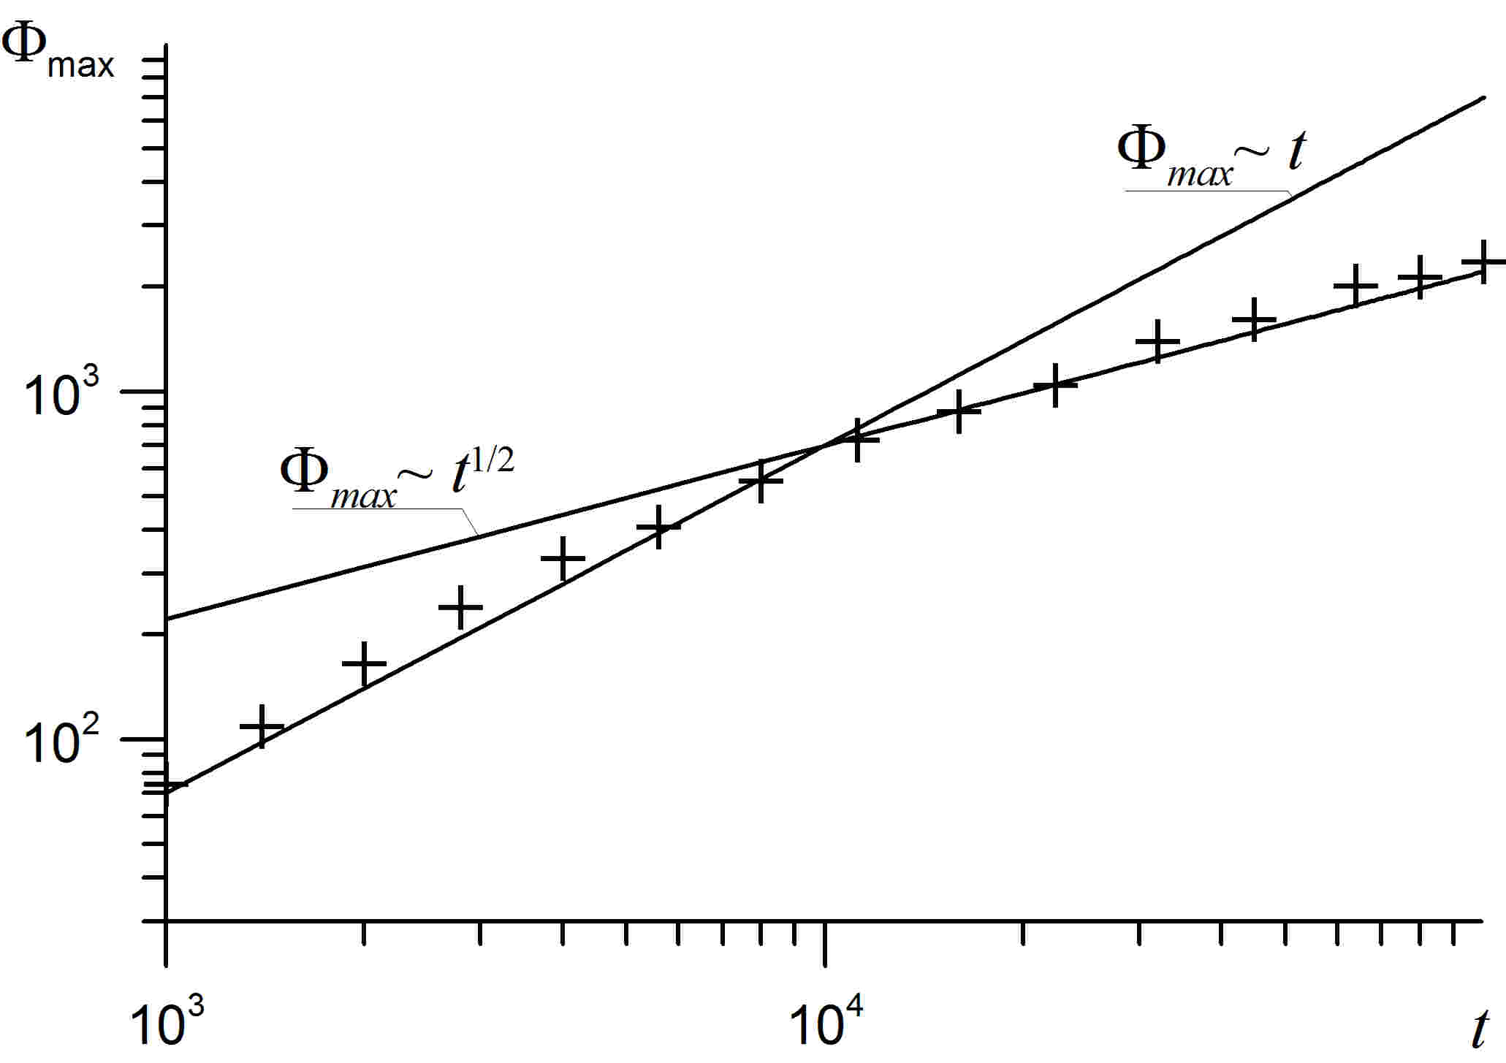
Figure 1. Time growth of maximal concentration of point particles in turbulent channel flow with .

(4)
At large times , the quasi-equilibrium approximation [1,3] of (3),(4) gives the following diffusion equation
, (5)
where , (cf. [1]).
We found the exact self-similar solution of (5) for the case of inertial particles with
, (6)
where .
The solution (6) describes the unsteady accumulation of inertial particles near the wall at large times, when all particles becomes diffusional. The latter is the consequence of the irreversibility of the transition from free-flight particles to diffusional one expressed by (5), since it is almost impossible for the former free-flight particle retarded near the wall to increase their velocity up to order of one values again. Particle concentration profile has the near-wall pike with magnitude growing as and the thickness collapsing as . According to (6) after the infinite time all particles will deposit the wall, so that at . The real particles have the finite radius , such that the solution (6) is valid at times . Beyond these times the regularized steady-state singularity solution [1] is reached. At large distances the particle concentration obeys the power law , which is similar to the steady solution obtained in [1].
We perform the stochastic Lagrangian simulations using the model [3] of turbulent channel flow at seeded with the point particles. The results of simulation corroborate the expression (6) (Fig.1). As seen from Fig.1, at the initial stage of accumulation the maximal concentration grows linearly with time, which can be explained with the help of another self-similar solution of (5) having the form .

References

[1] D.Ph.Sikovsky. Singularity of inertial particle concentration in the viscous sublayer of wall-bounded turbulent flows. Flow, Turb. and Comb. 92: 41-64 ,2014.
[2] A. Soldati, C. Marchioli. Physics and modelling of turbulent particle deposition and entrainment: Review of a systematic study. Int. J. Multiphase Flow 35: 827-839, 2009.
[3] D.Ph.Sikovsky. Stochastic Lagrangian simulation of particle deposition in a turbulent channel flows. 10th International ERCOFTAC Symposium on Engineering Turbulence Modeling and Measurements, Marbella, Spain, 17-19 September 2014. DOI: 10.13140/2.1.4204.6722.

