ENTRAINMENT STUDIES IN CLOUD-LIKE FLOWS USING NOVEL SCANNING TOMOGRAPHY TECHNIQUE

Kanwar Nain Singh¹ & Sreenivas K.R.¹
¹Jawaharlal Nehru Centre for Advanced Scientific Research, Bangalore, India

Abstract
Clouds are one of the major sources of uncertainty in climate prediction .The present work is to study the dynamics of orographic clouds. We considered a planar turbulent wall jet with off source volumetric heating as an appropriate low order fluid-dynamical model for studying the turbulence and entrainment in orographic-clouds. Entrainment was found to reduce drastically with the off-source volumetric heat addition. We found that the reduction of entrainment started at a bulk-Richardson number which was an order of magnitude smaller than that seen in earlier experiments [1] on free standing cumulus clouds. This is consistent with observations in real orographic clouds which develop as a thin sheet rising along the mountain slope. We have developed a novel scanning tomography technique for getting concentration field in turbulent shear flows. This technique is being applied on cloud-like flow to understand the entrainment characteristics. Detailed results will be presented at the conference.

INTRODUCTION
Clouds are one of the major sources of uncertainty in climate prediction (IPCC Fourth Assessment Report: Climate Change 2007), and was also listed as “the most urgent scientific problem requiring attention” by the Second Assessment Report - IPCC 1995. Also, convective clouds are of utmost importance to study the dynamics of tropical meteorology and therefore, play a key role in understanding monsoons. Cloud formation and its development is a complex phenomenon, which includes (a) mass transport by cumulus convection, (b) phase change, (c) interactions with the sub-cloud-layer, (d) interactions with radiation, and (e) mechanical interactions with the mean flow [2]. These factors make it very difficult to study cloud flows at laboratory conditions. Orographic clouds are formed when moist air parcels are forced to move up because of surface topography. Orography certainly has a significant effect on atmosphere. One of the estimates indicates that seasonal mean precipitation would reduce by 25% if orography was removed all around the world [3]. So parameterization of these clouds would lead to accurate forecasting of precipitation. Scientists have been studying the effect of orography for a long time. But the current models being used do not represent several mechanisms, particularly those associated with distortion of vorticity and the structure of turbulence due to phase change. The aim of the present study is to experimentally study the orographic cloud-like flow and determine some parameters related to vortical structures which could later be incorporated to the models to improve their accuracy.

EXPERIMENTAL SETUP AND METHOLOGY
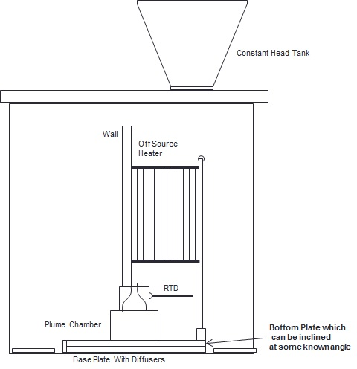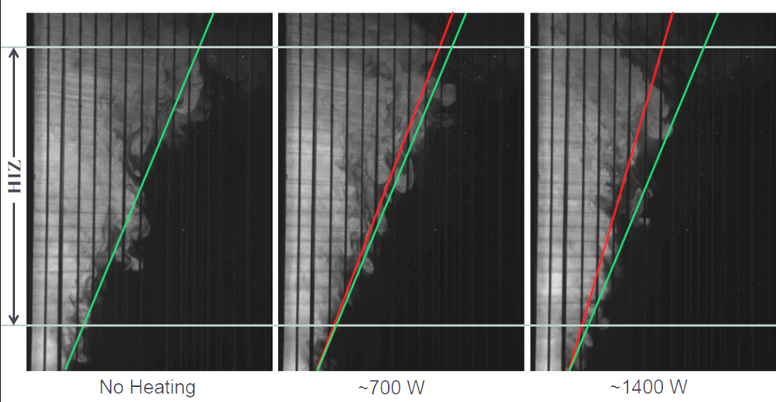
Figure 1: (a) Schematic of Orographic cloud-like flow producing setup, and (b) instantaneous PLIF images of flow with and without heating.
When the moist air parcel is forced to move up the mountain slope, adiabatic expansion happens and there comes a level where condensation starts resulting in formation of orographic cloud. The latent heat released gets added to the cloud fluid which starts following pseudo-adiabatic lapse rate. We considered planer turbulent wall jet as an appropriate low order fluid dynamical model for orographic clouds. Flow was volumetrically heated to mimic the latent heat released in real clouds. A setup was fabricated capable of producing a uniform wall jet. A set of heating grids were placed parallel to the wall as shown in the schematic (Figure 1) and each alternate heating grid was connected to one polarity of the power source. To have a dynamical similarity, we match the bulk Richardson number (Bhat and Narasimha, 1996) to that in real convective clouds. The bulk Richardson number is given by, G=βgQ/ρC_{p}bU³. By varying the heat addition rate (Q), we can achieve dynamically similar flows in laboratory conditions.
3D TOMOGRAPHY TECHNIQUE
Turbulent mixing of passive scalar is very important in many environmental flows such as flow from a chimney, clouds, etc. The turbulent mixing, even in the simplest flows is inherently three dimensional. Therefore, planar measurements, at times, may be misleading and give spurious results. The idea is to sweep through the flow field at fast enough speed so that flow could be assumed as ‘frozen’ and then reconstruct three dimensional concentration field after processing two dimensional raw images. The schematic of the setup is shown in figure 2 and also the iso surface of three dimensional structure is shown.
Figure 2: (a) Schematic of scanning tomography technique setup, and (b) reconstructed three dimensional structure.

RESULTS AND DISCUSSIONS
As authors were not aware of any previous study which could tell the bulk Richardson number in orographic clouds, we slowly kept increasing the heat addition to see how entrainment characteristics changes (Figure 1 (b)). It was found that the scalar width started reducing at a bulk Richardson number which was an order of magnitude smaller than that seen in experiments by [1] on free standing cumulus clouds. This was consistent with observations in nature where orographic clouds develop as a thin sheet of clouds rising along the mountain slope, although natural tendency of buoyancy addition is to make it spread in direction opposite to gravity. The novel scanning tomography technique developed was also successfully validated for an axisymmetric jet. Now the technique is being extended to study the evolution of cloud-like flows. Quantitative detailed results will be presented at the conference.
References
[1] Narasimha, R., Diwan, S. S., Duvvuri, S., Sreenivas, K. R., & Bhat, G. S. (2011). Laboratory simulations show diabatic heating drives cumulus-cloud evolution and entrainment. Proceedings of the National Academy of Sciences, 108(39), 16164-16169.
[2] Arakawa, A. (2004). The cumulus parameterization problem: Past, present, and future. Journal of Climate, 17(13), 2493-2525.
[3] Chakraborty, A., Nanjundiah, R. S., & Srinivasan, J. (2002). Role of Asian and African orography in Indian summer monsoon. Geophysical research letters, 29(20), 50-1.

