TUNING TRANSITIONS IN ROTATING RAYLEIGH-BÉNARD TURBULENCE

Pranav Joshi¹, Rudie Kunnen¹ & Herman Clercx^{1,2}
¹Department of Applied Physics, Eindhoven University of Technology, Eindhoven, The Netherlands
²Department of Applied Mathematics, University of Twente, Enschede, The Netherlands

Abstract Rayleigh-Bénard convection is a canonical system for the investigation of buoyancy-driven natural convection phenomena which abound in nature and technology. Under the influence of rotation and depending on the system parameters, the flow exhibits different regimes with disparate heat transfer characteristics even in the turbulent state. The present study attempts to tune the transitions between these regimes and thus control the heat transfer in practical applications. In particular, we explore the effect of addition of neutrally-buoyant thermally-conducting particles to the fluid. Following an experimental approach, we study the flow structure and heat transfer as functions of particle concentration and system parameters.
INTRODUCTION AND BACKGROUND
Rayleigh-Bénard (RB) turbulence is a model system to study buoyancy-driven convection in many technological applications and environmentally relevant phenomena. As many of these flows are subjected to rotation, its influence on the RB system has also been studied over the past few decades. As first shown by Chandrasekhar [1] using stability analysis and observed experimentally by Rossby [2], rotation stabilizes the RB system and delays the onset of convection. However heat transfer as measured by the Nusselt number, Nu=hL/k, can increase abruptly as the strength of rotation becomes comparable to that of buoyancy, i.e. Rossby number Ro=U/ΩL~1, and then decay at higher rotation rates, Ro<~0.1 (confer figure 1). Here k, h, L, U and Ω are the thermal conductivity of the fluid, heat transfer coefficient, height of the RB cell, characteristic buoyancy driven velocity and rotation rate, respectively. The large scale circulation (LSC), which is a prominent feature of turbulent non-rotating RBC, ceases to exist under rotation. The line plumes emanating from the heated and cooled surfaces are replaced by an array of vertical vortices which span a substantial fraction of the RB cell height [3]. These columnar vortices carry hot fluid from the heated bottom plate to the cooled top plate and vice versa. Furthermore, the character of the boundary layers changes to that of the thinner Ekman layers. At moderate rotation rates these transformations in the flow structure result in an increase in heat transfer by up to 20% in comparison to the non-rotating case [3]. However at higher rotation rates, heat transfer decreases again as vertical velocity fluctuations are increasingly damped in the geostrophic regime. The RB system can thus exist in disparate states depending on the rotation rate. The present study attempts to control the transition between these regimes. In particular, we focus on adding thermally conductive near-neutrally-buoyant particles to the fluid to change the flow structure and hence control heat transfer in practical applications.

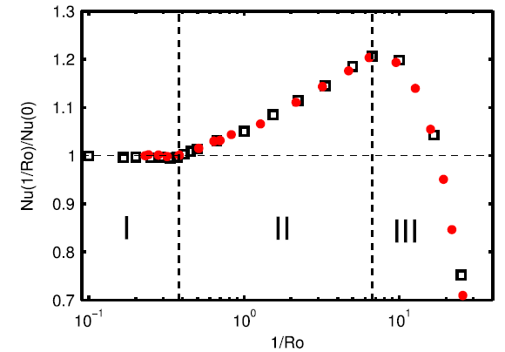
Figure 1. Heat transfer enhancement as a function of rotation rate. Red dots represent data from experiments while black open squares show results of numerical simulations. Ra=2.73×10⁸, Pr=6.26, Γ=1 (definitions to follow in the text). Figure reproduced from [3].

EXPERIMENTAL SETUP AND MEASUREMENT PROCEDURE
A schematic of the experimental setup is shown in figure 2 (not to scale). The RB cell consists of top and bottom copper plates, CP, and cylindrical Plexiglass side wall, SW, which is 250 mm tall and has an inner diameter D=250 mm, resulting in an aspect ratio Γ=D/H=1. The bottom copper plate is heated by using resistors, RH, fitted in the plate while cooling water, CW, is recirculated through the top plate. Heat losses are minimized by using secondary heaters SH which maintain the adiabatic shields, AS, at the same temperature as the corresponding walls of the RB cell. In addition to providing the insulating shields, IS, the entire setup is enclosed in a wooden box which is lined on the inside by an insulating material. The RB cell is provided with an air-bleed outlet, BT, close to the top plate. Water is used as the working fluid. Five thermistors, TS, are provided in each of the plates CP while the side walls contain 24 thermistors in three rings of 8 equi-spaced sensors each, located at elevations 0.25H, 0.5H and 0.75H from the bottom surface of the cell. This setup is mounted on a rotating table facility which can achieve rotation rates up to 10 rad/s. The primary diagnostic consists of heat flux and wall-temperature measurements which can be used to calculate the Nusselt number and draw inferences about the flow structure. To achieve high thermal conductance and neutral buoyancy, we use ~90-105 μm diameter hollow ceramic particles which are coated with a 450 nm thick silver layer and have a resultant density of 0.97-1.02 g/cm³. Before introducing them in the flow, the RB system is allowed to reach a statistically steady state. A mixture of particles and water at mean temperature of the RB system is then injected into the cell using a syringe and a tube, IT, inserted through the air-bleed conduit.

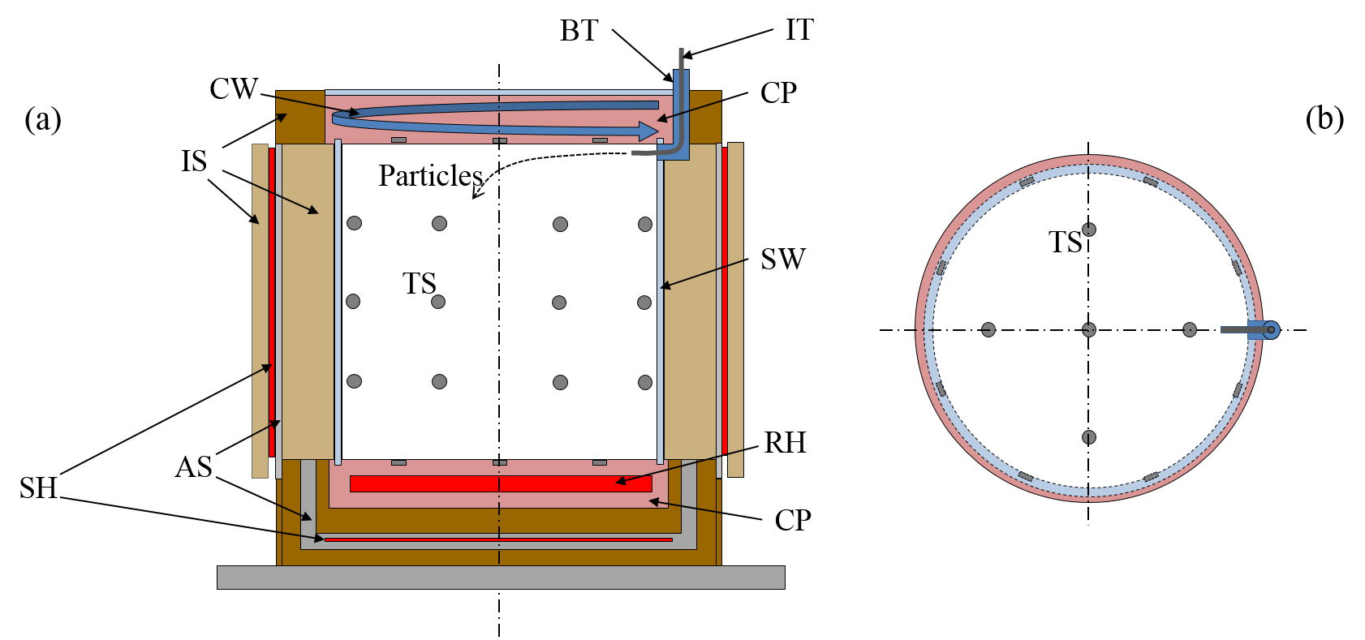
Figure 2. Schematic of the Rayleigh-Bénard cell: (a) side view; (b) top view.
Preliminary tests are currently being performed to establish the experimental protocols. The parameter space to be explored is 10⁹≤Ra≤10¹⁰, 4≤Pr≤9, ∞≤1/Ro≤0.02 and particle concentration, ϕ, up to ~5%. Here standard definitions of Ra and Pr apply, viz., Ra=gαΔTL³/νκ and Pr=ν/κ, where α, ν, and κ are the volumetric thermal expansion coefficient, kinematic viscosity and thermal diffusivity of the fluid, respectively, ΔT is the temperature difference between the bottom and top plates and g is the gravitational acceleration. A slight density mismatch between the fluid and particles can result in particle concentration gradients and hence novel fluid-particle interactions, especially at high ϕ. Effects of particle-addition can include modification of heat transfer rate and changes in the locations of regime transitions in the parameter space, e.g. the sudden onset of increased Nu observed in figure 1 can occur at lower rotation rates. Such effects on the system can provide us with additional degrees of freedom to tune heat transfer in practical applications. Measurements of Nu and wall-temperature profiles at different particle concentrations will be the first step in assessing the impact of particles on the flow, and the results of these investigations will be presented at the conference.
ACKNOWLEDGEMENT
Financial support for the present study is provided by the Foundation for Fundamental Research on Matter (FOM).

References
[1] Chandrasekhar, S., 1961, Hydrodynamic and hydromagnetic stability., Oxford University Press.
[2] Rossby H.T., 1969, “A study of Bénard convection with and without rotation,” J. Fluid Mech., 36(2), pp. 309–335.
[3] Stevens, R. J. A. M., Clercx, H. J. H., and Lohse, D., 2013, “Heat transport and flow structure in rotating Rayleigh–Bénard convection,” Eur. J. Mech. - B/Fluids, 40, pp. 41–49.

