ROUGHNESS INDUCED BOUNDARY LAYER TRANSITION IN INCOMPRESSIBLE FLOW

Qingqing Ye¹, Ferry F.J. Schrijer¹ & Fulvio Scarano¹
¹Faculty of Aerospace Engineering, Delft University of Technology, Delft, the Netherlands

Abstract The fluid dynamics process leading to laminar-turbulent transition behind an isolated roughness element is investigated in the incompressible regime using particle image velocimetry. The study covers the effect of roughness size and geometry on the promotion of transition. The measurement domain covers a large streamwise range from the near wake to the onset of the turbulent regime. Planar PIV measurements reveal the basic flow pattern and the turbulent structure of the flow characterizing by the velocity fluctuation statistics (RMS of the streamwise and wall-normal velocity component and Reynolds shear stress). The high Reynolds shear stress level reaching the region near the wall in the downstream area indicates the onset of turbulent boundary layer.

INTRODUCTION
Surface roughness usually acts as disturbance source accelerating the transition process. The efficiency of three-dimensional roughness elements in promoting transition strongly depends on their size (eg. height and span) and geometry. The basic flow pattern around different geometries (hemisphere[1], cylinder[2], and micro ramp[3]) has been identified separately in subsonic flow. The effect of geometry on boundary layer transition efficiency was investigated by flow visualization in supersonic boundary layer[4][5]. However, only qualitative data about the geometry effect was achieved. Qualitative analysis is needed to properly study the effect of roughness size and geometry on the acceleration of transition in subsonic regime.
The present work focuses on the effect of roughness element of various geometries and size on laminar to turbulent transition in subsonic flow. In order to have a quantitative comparison on both the flow structure and the efficiency in which the roughness triggers transition, particle image velocimetry is employed. The measurement domain covers a large streamwise range in order to follow the evolution of the vortical structures and transition process. Four types of geometries, micro-ramp, cylinder, square and semi-sphere of different sizes are studied. The instantaneous flow structure illustrates development of the shear layer encompassing the wake of the element. The turbulent properties are studied to compare the onset of turbulent boundary layer induced by different roughness.

EXPERIMENTAL SETUP AND MEASUREMENT TECHNIQUE
Experiments were carried out in the open jet low speed wind tunnel (W-tunnel) in the Aerodynamics Laboratories of the Aerospace Engineering Department at TU Delft. The W-tunnel has a test section of 0.4×0.4m² and operates at room temperature and pressure. The reported turbulence level in the freestream is approximately 0.5%. An aluminum flat plate with a size of 600×400×10mm³ was placed paralleled to the flow direction. The roughness elements were taped to the plate at 290mm from the leading edge. Various geometries (micro-ramp, cylinder, square and semi-sphere) and sizes are studied. The characterization of the roughness induced boundary layer are measured by planar PIV. The laser illumination was provided by Quantel CFR PIV-200 Nd: YAG laser (200mJ/pulse, 532nm wavelength, 9ns). The pulse separation time is 40µs. The illumination laser sheet with a thickness of approximately 1.5mm, is oriented from the back of the plate to reduce wall reflections. Water-glycol droplets of 1µm diameter at a concentration of approximately 4 particle/mm³ were used as seeding. A single LaVision Imager Pro LX interline CCD camera (4872×3248pixels, 7.4µm/pixel) was equipped with an objective of 60mm focal length to record the images. The measurements consists of 1000 snapshots acquired at a frequency of 4Hz.

RESULT
Some preliminary results are shown in Figure 2 and 3, demonstrating the transitional wake of micro-ramp. The sketch of micro ramp is shown in Figure 1. Two ramp geometries (ramp-1, ramp-2) are selected in the experiment. The height of both ramps is the same (h₁=h₂=2mm), which means that the Reynolds number based on the the roughness-height is unaltered. The span and length are different: c₁=4mm, l₁=4.5mm and c₂=3c₁=12mm, l₂=3l₁=13.5 respectively. Experiments were conducted at freestream velocity of 5m/s.
The instantaneous flow pattern is shown in the streamwise-wall normal (x-y) cross-section of the spanwise vorticity contour in Figure 2. In the wake structure of the ramp-1, vortex shedding can be detected in the wake starting from x/h=12, showing an undulating behaviour in the shear layer between the wake and freestream. The production of these vortices is attributed to Kelvin-Helmholtz instability. The vortices show a hairpin shape with head and leg portion, inclining towards x-axis. The spacing between neighbouring vortices is regular and has a pitch of approximately λ/h=5. The head detaches from the leg portion at x/h=35. Starting from x/h=63, two neighbouring vortex heads approach, indicating the onset of a pairing process. The x-y cross section of Reynolds shear stress is shown in Figure 3. A large positive peak is observed at the upper edge, indicating the presence of an unstable shear layer due to the vortex shedding. The magnitude of the peak attenuates when moving downstream. Upwash motion generated by the leg portion of hairpin vortices leads to a secondary peak as a branch of the upper peak at x/h=12. This peak moves closer to the surface of the model and diffuses in the wall normal direction. The secondary shear peak is conductive to transport high momentum fluids to the near wall region. Looking at ramp-2 with larger span and length, similar vortex structure is shown in the bottom contour of Figure 2. The onset location of vortex shedding moves downstream to x/h=25. Consequently, the production of unstable upper shear layer also moves downstream (Figure 3). The spacing increases to λ/h=8. The head portion starts to detach from the leg at x/h=49. No pairing process can be detected in the measurement domain. Higher upper and secondary peak value of Reynolds shear stress are found, causing stronger momentum transport process. The diffusion of the secondary peak in the Reynolds shear stress is less intense.

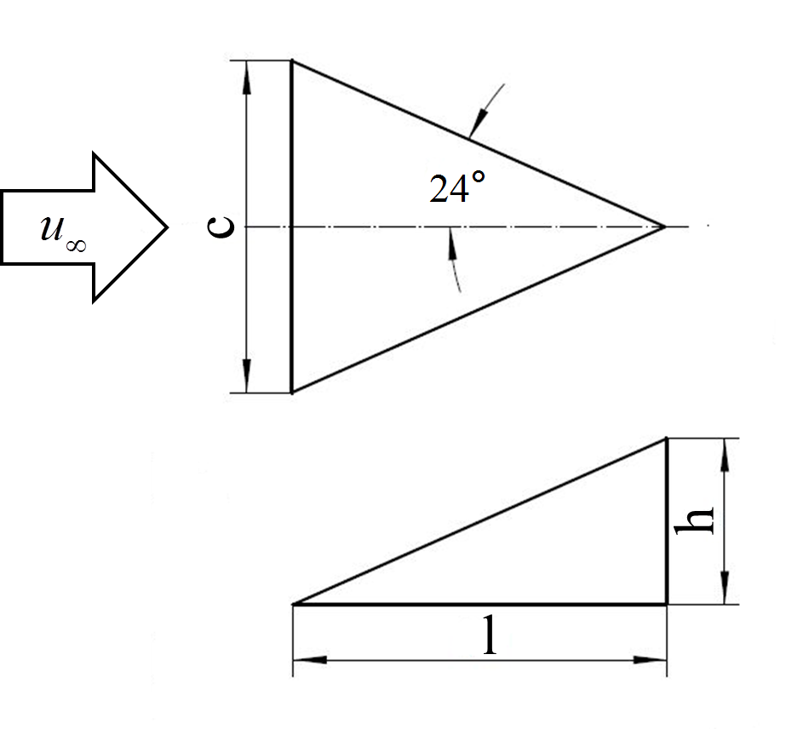
Figure 1. Configuration of micro ramp
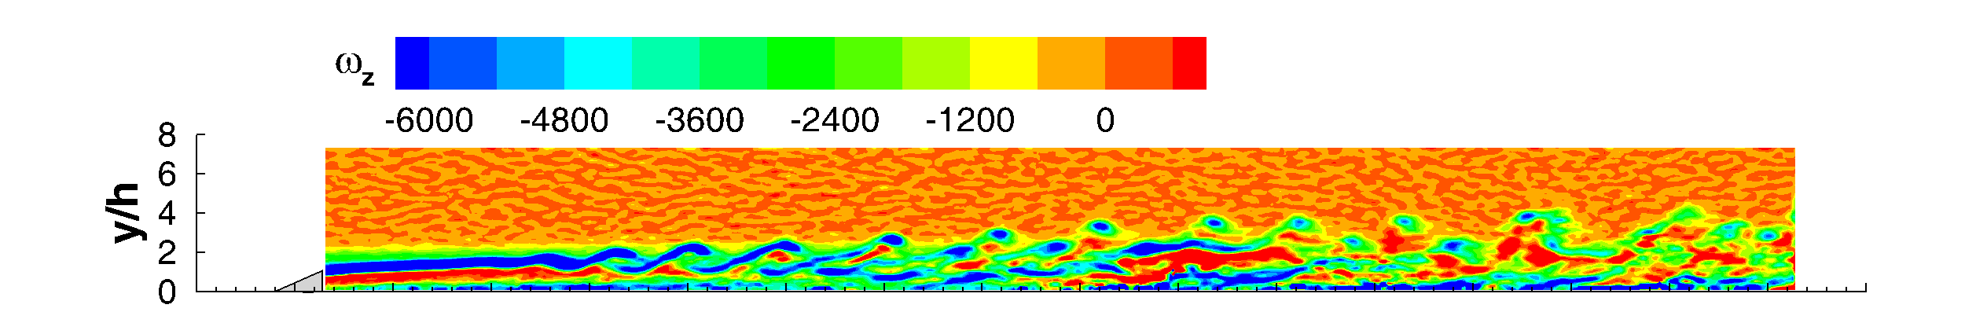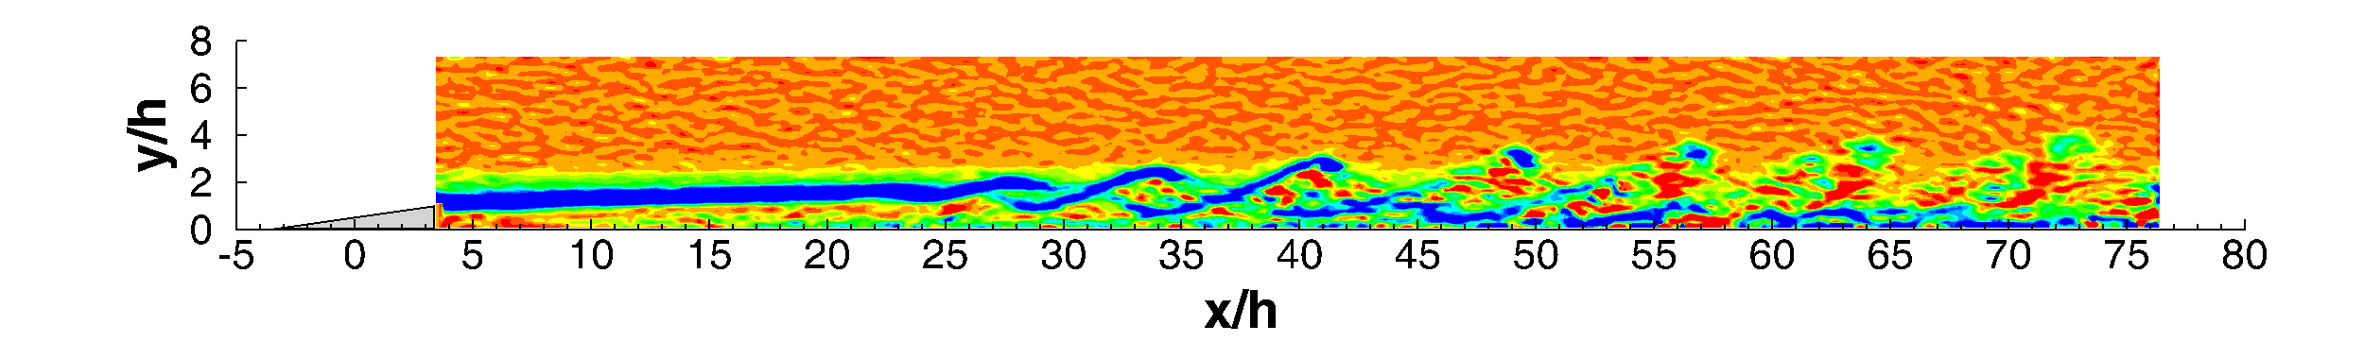
Figure 2. Contour of spanwise vorticity ω_{z} (up: ramp-1; bottom: ramp-2)
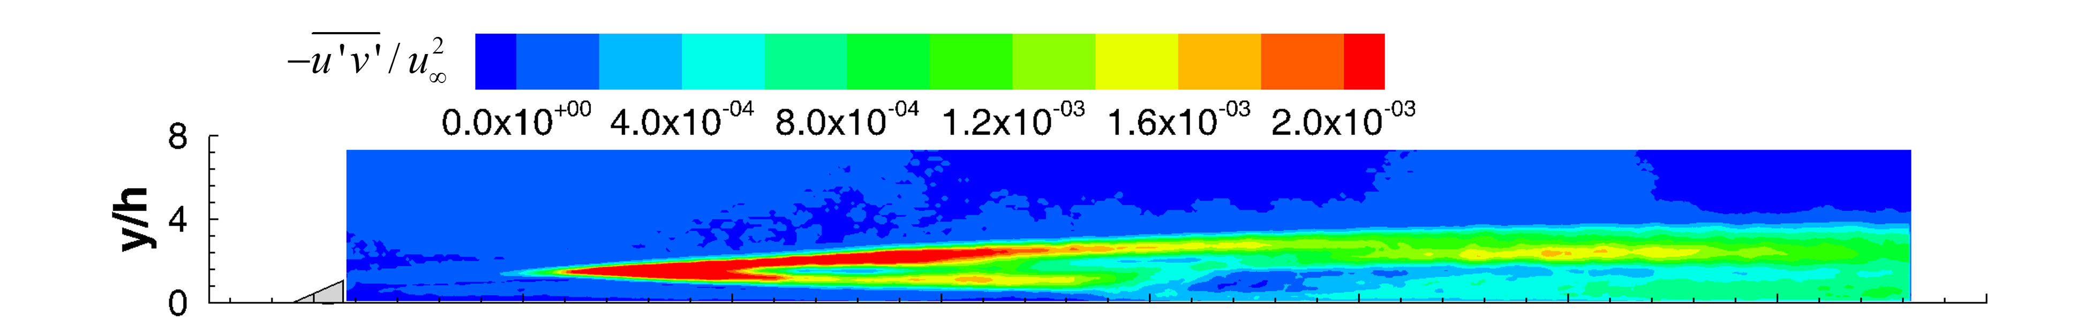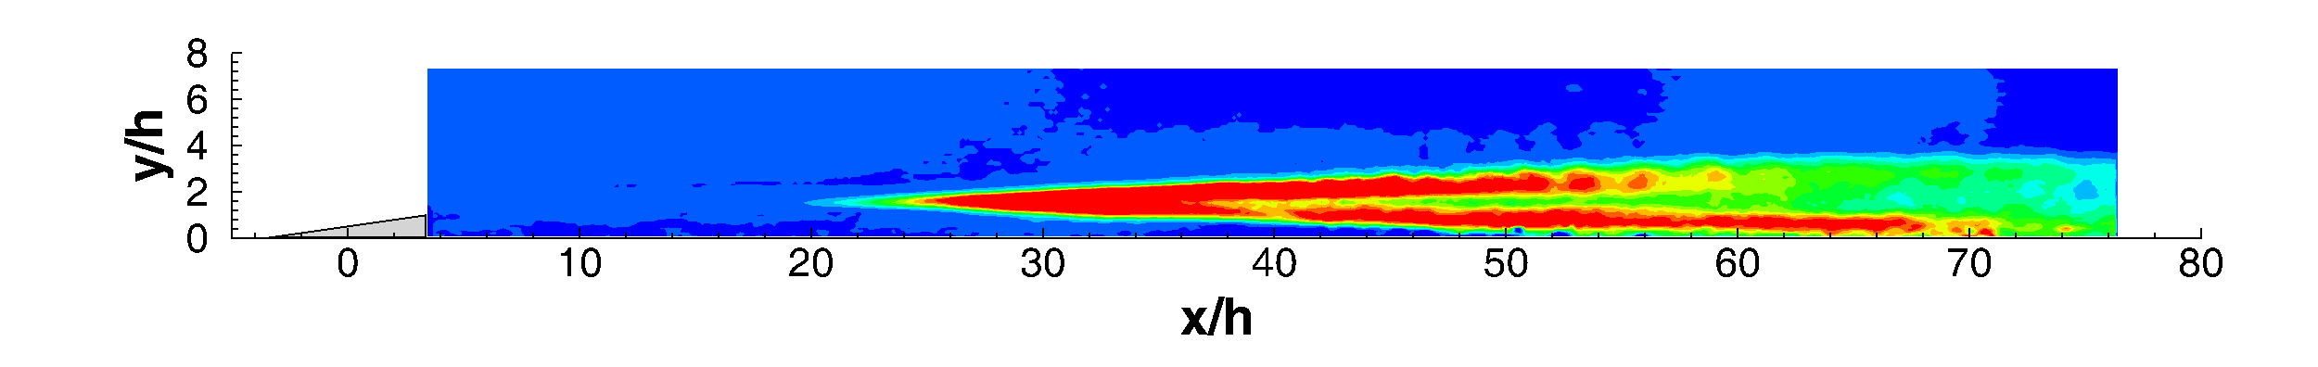
Figure 3. Contour of Reynolds shear stress (up: ramp-1; bottom: ramp-2)

References
[1] M. S. Acarlar, and C. R. Smith. A study of hairpin vortices in a laminar boundary layer. Part 1. hairpin vortices generated by a hemispherical protuberance. Journal of Fluid Mechanics 175: 1-41, 1987.
[2] F.G. Ergin, and E.B. White. Unsteady and transitional flows behind roughness elements. AIAA Journal 44(11): 2504-2514, 2006.
[3]Q. Ye, F.F.J. Schrijer, and F. Scarano. A Tomographic PIV Study on Boundary Layer Transition Induced by Isolated Roughness. 4th International Conference of Experiment Fluid Mechanics, 12-15 Aug 2014, Beijing, China.
[4] Danehy, C. B. Ivey, J. A.Inman, B. F. Bathel, S. B. Jones, A. C. McCrea, N. Jiang, M. Webster, W. Lempert, J. Miller, and T. Meyer. High speed PLIF imaging of hypersonic transition over discrete cylindrical roughness. AIAA 2010-703, 2010.
[5] S. C. Tirtey, O. Chazot, and L. Walpot. Characterization of Hypersonic Roughness-Induced Boundary-Layer Transition. Experiment in Fluids 50: 407–418, 2011

