DNS OF TRANSITION TO NONUNIFORM IN TIME AND/OR SPACE TURBULENT FLOWS
IN ROTATING SPHERICAL LAYERS

Krivonosova Olga¹, Zhilenko Dmitry¹
¹Institute of Mechanics, Moscow State University, Moscow, Russia

Abstract We have numerically studied the transition to turbulence in a layer of a viscous incompressible fluid confined between concentric counter rotating spherical boundaries. Rotational speeds of one or two boundaries were periodically modulated. The transition to turbulence was caused by an increase in the modulation amplitude. Two different cases of transitions were under consideration. In the first case modulation of outer sphere velocity with constant inner sphere speed was imposed on initial periodical flow state. The obtained solutions reveal cycle-chaos intermittency type - irregular temporal alternation of laminar and turbulent states occupying the whole layer. In the second case both of spheres were opposite-phase oscillated at the same frequency and amplitude about the state of rest. The obtained solutions exhibits chaos-chaos intermittency type of the flow - irregular temporal alternation of weak and strong turbulent states in the limited part of the layer, outside which the flow remains periodical.

INTRODUCTION

The transition to turbulence is frequently accompanied by intermittency- irregular spatial and/or temporal alternation of laminar and turbulent fragments in the flow. This intermittency was observed for pipe flows [1] and closed flows with counter-moving boundaries: plane, cylindrical and spherical Couette flows (SCF) - flow of fluid confined between concentric spherical boundaries. In this work we numerically study possibility of transition to turbulence through intermittency in SCF with modulated rotational speed of one or two boundaries. The transition occur with arising in the modulation amplitude A. The flows arising under modulation action may be important for geophysical applications: non-uniform rotation of planets about its axis and influence of periodical in time external forces on the Earth atmosphere. Two different cases of transitions with counter rotating boundaries were under consideration. In the first case modulation of outer sphere velocity with constant inner sphere speed was imposed on initial periodical flow state. Averaged Re numbers are Re₁ = Ω₁ r²₁ /ν = 413 for inner sphere, and Re₂ = Ω₂ r²₂ /ν = - 900 for outer sphere. Relative layer thickness δ=(r₂ - r₁)/ r₁=1. Here ν is the kinematic viscosity of the fluid, confined between the iiner and outer sphere with radii r_{i} and rotating with angular velocity Ω_{i}. In the second case both of spheres were oscillated with phase shift π at the same frequency and amplitude beginning about the state of rest. Modulation frequencies f = 0.01 Hz for the first case and f = 0.5 Hz for the second case were used. The flow of viscous incompressible fluid in a spherical gap is described by the Navier-Stokes and continuity equations in spherical coordinate system with the radial (r), polar (θ) and azimuthal (φ) directions. No-slip and non percolation conditions are imposed on the boundaries. The computation algorithm was based on a finite-difference scheme of discretization for the Navier-Stokes equations and a semi-implicit third order accurate Runge-Kutta scheme for integration with respect to the time. Spatial discretization was carried out on non-uniform grids with respect to r and θ, the total number of nodes was 5.76 10⁵ .
CALCULATION RESULTS
In the first case as initial was used periodical flow, resulting from reciprocal synchronization of frequencies of the preceding flow state with three independent frequencies in the spectrum ( approach of phase velocities for three linear modes). Modulation amplitude arising upper than Re_{m2} = (A Re₂) (2ν/2πf)^{1/2} / r₂ ≥ 13.2 leads to transition to chaos of the flow. Near a threshold of the chaotic flow state formation calculation result show the presence of cycle-chaos intermittency type-irregular alternating of turbulent and laminar time intervals, occupying the whole layer. In laminar (periodical) regions the frequency correspond to that in the initial flow. It can be suggested that transition to turbulence upon increase in the A is related to the breakage of the regime of synchronization in the initial flow, while the intermittency is related to a short-time existence of conditions favoring the restoration of synchronization. Let us consider how the phase velocities of linear modes change under the action of outer sphere angular velocity modulation. For this aim analysis of linear stability of flow has been carried out in a quasi - steady -state approximation. Assumption, that this stability is determined by the field of flow velocity at the current moment of time, was used. Results of using this approach shows that phase velocities of linear modes may differ from the analogous values obtained under steady-state boundary conditions. As A increase, the angular phase velocity changes not only in magnitude, but in direction as well, and directions does not change simultaneously for all modes. This means that synchronization is impossible in the interval of modulation phase, where different directions of phase velocities of linear modes are observed. If synchronization is impossible, it means transition to chaos. Outside of this phase interval phase velocities of linear modes have the same values and retain their direction, which provides conditions for the restoration of synchronization. So, flows of two types, chaotic and synchronized, are observed, which creates the prerequisites for the existence of flows with intermittency cycle-chaos type. An increase in the A leads to decrease in the interval of phases for which the angular velocities of linear modes retain the same direction and have close values. This may imply a decrease in the duration of flow states with synchronization, which can be observed in calculation results. Thus, our analysis of the behavior of phase velocities of propagating linear modes explains both the appearance of chaos and its some features.
In the second case - in the presence of the opposite-phase oscillations of spheres - flow is symmetric relative to the axis of rotation and equatorial plane up to Re₁=55 (Re₁ = 2Ar₁/2πfδ, δ=(2ν/2πf)^{1/2}). As Re₁ increases the flow lose its stability and becomes asymmetric relative to the rotation axis. Near the inner sphere azimuthal wave number is m=1, near the outer sphere m=2. The velocity spectrum exhibits a second frequency f₁ ˂˂ f. At Re₁ ≥ 65 correlation dimension value D, calculated from azimuthal velocities time series, falls in interval 3.5 ˂ D ˂ 4, we may conclude that the flow becomes turbulent. It was shown that D is more large at middle latitude near outer sphere (point 2) as compared to the equatorial region near inner sphere (point 1). As can be seen from fig.1, the behavior of velocity near the inner sphere and equator plane (curve 1) is close to periodic, while flow near the outer sphere at middle latitudes (curve 2) is close to turbulent. So, the flow is spatially and temporally non-uniform. Turbulence develops in a limited region and remains laminar outside this region. The degree of temporal no-uniformity can be determined from phase difference between inner sphere angular velocity and velocity of the floew in point 1,2. Instantaneous phase Ψ(t) of velocity x(t) is define as Ψ(t)= arctan(y(t)/x(t)), where y (t) is the orthogonal complement to x(t), which is calculated as the Hilbert transform of the x(t) series. d/dt (Ψ(t)) is then instantaneous frequency. The phase difference at point 1 (curve 3) remains constant in time, while the frequency difference exhibits regular variations (curve 6). Thus, the flow at point1 is fully synchronized with rotation of the boundary. At point 2 these parameters vary in time. It possible to reveal fragment of weak turbulence, where strong synchronization makes the phase difference constant and the frequency difference exhibits no jumps. The region of strong turbulence and weak synchronization, the phase difference varies with the time and the frequency strongly deviates from averaged values. Fragments of weak and strong turbulence are randomly alternating in time, which leads to the conclusion that there is chaos-chaos type intermittency. It can be suggested that the approach describe above, which is based on the concept of phase/frequency difference, can be used for determining boundaries both between the turbulent/non-turbulent regions of flow and between regions of temporally uniform/non-uniform turbulence.

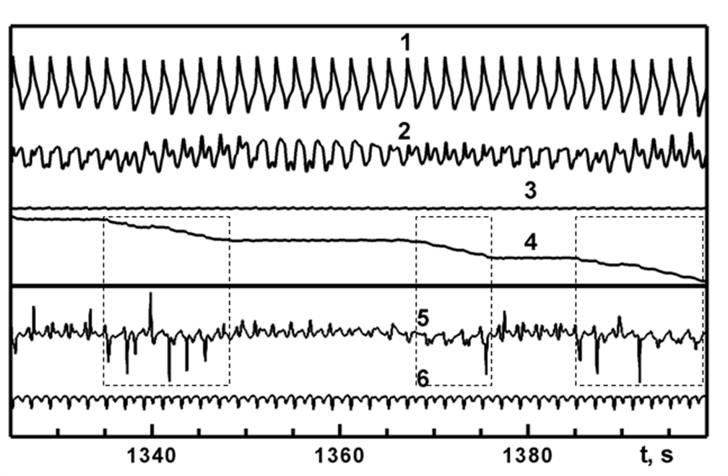
figure1. Time series of azimuthal flow velocity (1,2) and differences of phases (3,4) and frequencies (5,6) between the inner sphere angular velocity and flow velocity near the inner (1,3,6) and outer spheres (2,4,5) vs time t for Re₁=72. The dashed contours indicate regions of stronger turbulence.

